A
REPORT ON
“INVENTORY MANAGEMENT SYSTEM”
SUBMITTED TO THE SAVITRIBAI PHULE PUNE UNIVERSITY IN THE PARTIAL FULFILLMENT OF THE REQUIREMENTS FOR THE AWARD OF THE DEGREE
OF
THIRD YEAR OF ENGINEERING
(COMPUTER ENGINEERING)
SUBMITTED BY

Mr. Abhishek Kalyan Nawale COTC21

UNDER THE GUIDANCE OF
Prof. A.H. Kagne


DEPARTMENT OF COMPUTER ENGINEERING
STES’S SINHGAD ACADEMY OF ENGINEERING
KONDHWA, PUNE 411048
UNIVERSITY OF PUNE
2025-26

DEPARTMENT OF COMPUTER ENGINEERING
STES’S SINHGAD ACADEMY OF ENGINEERING
KONDHWA, PUNE 411048

CERTIFICATE
This is to certify that the report entitle
“Inventory Management System”
Submitted by
Mr. Abhishek Kalyan Nawale COTC21

is a bonafide work carried out by him/her under the supervision of Prof. A.H. Kagne and it is submitted towards the fulfillment of the requirement of Savitribai Phule Pune University, for the award of the degree of Third year of Engineering (Computer Engineering).

Prof . A. H. Kagne Prof. S. N. Shelke
Guide Head,
Department of Computer Engineering Department of Computer Engineering

Dr. M. S. Rohokale
Principal,
Sinhgad Academy of Engineering, Pune – 48

ACKNOWLEDGEMENT

I would like to thank Prof. A. H. Kagne for helping/Guiding me out in selecting the topic and contents, giving valuable suggestions in preparation of Seminar report and presentation.
I am grateful to Prof. S. N. Shelke, Head of Computer Department, for providing healthy environment and facilities in the department. He allowed us to raise our concern and worked to solve it by extending his co-operation time to time.
Goal makes us to do work. Vision is more important than goal which makes us to do work in the best way to make work equally the best. Thanks to Principal, Dr. M. S. Rohokale for his support and vision.
Consistent achievement requires boost on consistent interval basis. Management has given full support and boosted us to be consistent and achieve the target. Thanks to management for their support.
Thanks to all the colleagues for their extended support and valuable guidance. I would like to be grateful to all my friends for their consistent support, help and guidance.

Mr. Abhishek Kalyan Nawale COTC21

ABSTRACT
The Inventory Management System (IMS) is a web-based application designed to streamline and enhance the process of managing inventory for businesses. As organizations face increasing challenges in supply chain management and inventory control, the need for efficient and effective solutions has become critical. This system aims to improve user experience by providing easy access to inventory data, real-time tracking, and automated reporting.
Featuring a user-friendly interface, the IMS allows users to easily monitor stock levels, manage product listings, and track item movements. Users can create accounts to access personalized dashboards that display key metrics and alerts regarding stock levels and reorder points. The backend is integrated with a robust database that securely stores information on products, suppliers, transaction history, and inventory levels.
Key features of the Inventory Management System include user registration and login, advanced search options for products, automated reorder notifications, and comprehensive reporting tools. The system also includes an administrative dashboard that enables managers to oversee inventory operations, generate reports, and optimize stock levels.
This project aims to significantly reduce operational inefficiencies for businesses while providing an engaging and intuitive interface for users. Utilizing modern web technologies, the IMS promises scalability and robustness, addressing the evolving needs of various industries.
Overall, the Inventory Management System not only simplifies the inventory management process but also enhances data accuracy and operational efficiency for organizations, catering to the demands of a rapidly changing market landscape. The system ultimately serves to improve decision-making and resource allocation, aligning business operations with strategic goals.

CONTENTS

CHAPTER NO. |  |  |  | NAME OF CHAPTER | PAGE NO.
1 |  |  |  | INTRODUCTION | 2
2 |  |  |  | PROBLEM DEFINITION | 3-4
3 |  |  |  | SOFTWARE REQUIREMENT SPECIFICATION | 5
4 |  |  |  | SYSTEM DESIGN | 6-7
 | 4.1 |  |  | Entity Relationship Diagram | 6
 | 4.2 |  |  | Relational Diagram | 7
5 |  |  |  | MODULES OUTPUT | 8-11
6 |  |  |  | MERITS & DEMERITS | 12-14
 |  | 6.1 |  | Advantages | 12
 |  | 6.2 |  | Disadvantages | 13
 |  | 6.3 |  | Application | 14
 |  | 6.4 |  | Future Scope | 15
7 |  |  |  | CONCLUSION | 16
8 |  |  |  | REFERENCE | 17

1.INTRODUCTION

In recent years, inventory management has undergone a significant transformation due to advancements in technology and the increasing complexity of supply chains. One of the most impactful developments has been the introduction of automated Inventory Management Systems (IMS), which offer businesses a streamlined and efficient way to manage their inventory levels, optimize stock control, and enhance operational productivity.
An Inventory Management System is a digital platform that enables users to monitor stock levels, track product movements, and manage orders from anywhere, providing a comprehensive overview of inventory in real time. This system can be integrated into existing enterprise resource planning (ERP) software, facilitating a seamless and user-friendly experience for businesses of all sizes.
The Inventory Management System project is designed to simplify the process of managing inventory through an intuitive web or mobile application. This platform allows users to efficiently track stock levels, manage suppliers, and analyze sales trends from the convenience of their own devices. Key features of the project include real-time inventory tracking, automated reorder notifications, and comprehensive reporting tools. By providing an efficient and reliable means of inventory management, the project aims to enhance overall operational efficiency, reduce excess stock, and improve decision-making for businesses. Additionally, the system may include features such as user-defined alerts, detailed analytics, and integration with sales platforms, making it a comprehensive solution for modern inventory management needs.

2.PROBLEM DEFINITION

In today's fast-paced digital landscape, the need for efficient inventory management has become increasingly important for businesses across various sectors. Traditional methods of tracking and managing inventory—such as manual record-keeping, spreadsheets, and outdated software—are often seen as inefficient and error-prone. These practices can lead to inaccurate stock levels, overstocking or stockouts, frustrated staff, and ultimately missed sales opportunities. To overcome these challenges, a modern Inventory Management System (IMS) is essential to provide a streamlined, effective, and data-driven approach for businesses, optimizing operations and enhancing profitability.

This project aims to develop an Inventory Management System that addresses the diverse issues organizations face in managing their inventory efficiently.

Key Problems Identified:

1. User Experience:
- Employees frequently struggle with cumbersome interfaces and difficulty accessing essential inventory data. A confusing system can lead to frustration, errors in stock handling, and reduced productivity.

2. Real-Time Tracking:
- Without real-time visibility into stock levels and movements, businesses may encounter problems such as overstocking or stockouts. This lack of immediate information can result in lost sales and dissatisfied customers.

3. Data Accuracy:
- Manual entries and outdated systems often lead to discrepancies in inventory records, affecting ordering decisions and financial reporting. Inconsistent data can compromise trust in inventory management processes.

4. Integration Issues:
- Many organizations find it challenging to integrate their inventory systems with other critical software, such as sales platforms and accounting tools. This can create information silos, complicating overall operations and hindering data analysis.

5. Scalability:
- As businesses expand or experience seasonal demand fluctuations, their inventory management systems must effectively manage increased traffic and larger datasets without sacrificing performance.

6. Reporting and Analytics:
- Organizations often lack adequate tools for analyzing inventory data, resulting in missed opportunities to uncover sales trends, customer preferences, and inventory turnover rates. This can impede strategic decision-making and operational efficiency.

This project seeks to create a comprehensive Inventory Management System that enhances user experience, streamlines inventory processes, and provides valuable insights for organizations while tackling these critical challenges. By leveraging contemporary technology, the system aims to improve inventory accuracy, operational efficiency, and overall profitability for businesses.

- SOFTWARE REQUIREMENT SPECIFICATION

Software Requirements:

  - Web Browser: Chrome, Firefox, Safari, or Edge
  - Database Software: MySQL, SQL Server
  - Front-end: Python
  - Integration Software: API Gateway, ESB, or Middleware
  - Security Software: Firewall, Antivirus, and Encryption
  - Backup and Recovery Software.

Hardware Requirements:
- Server: 2 GHz Processor, 8 GB RAM, 500 GB Storage
- Client: 1 GHz Processor, 4 GB RAM, 100 GB Storage
- Network: High-Speed Internet Connection
- Storage: Secure and Redundant Storage Solution.

- SYSTEM DESIGN

4.1 ER Diagram:-

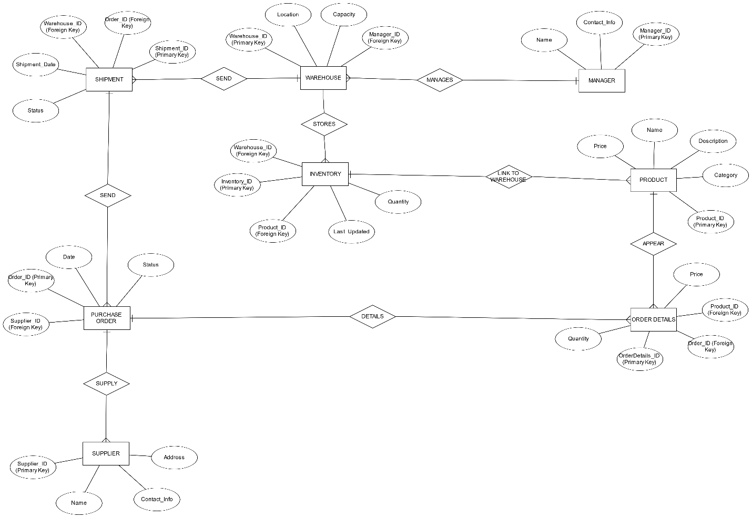

4.2 Relational Schema:-

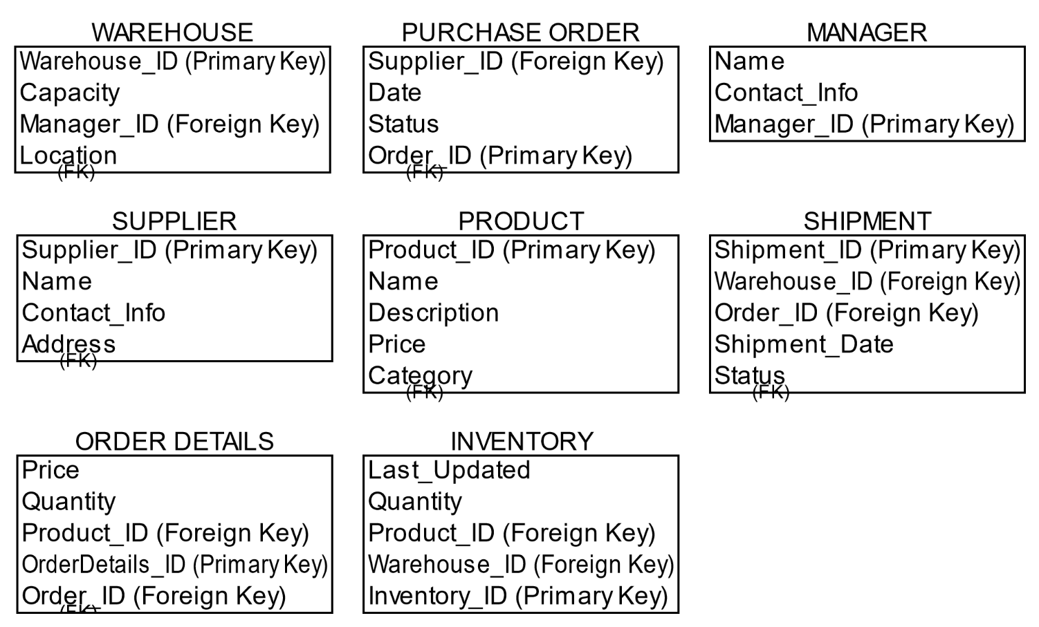

- MODULES OUTPUT

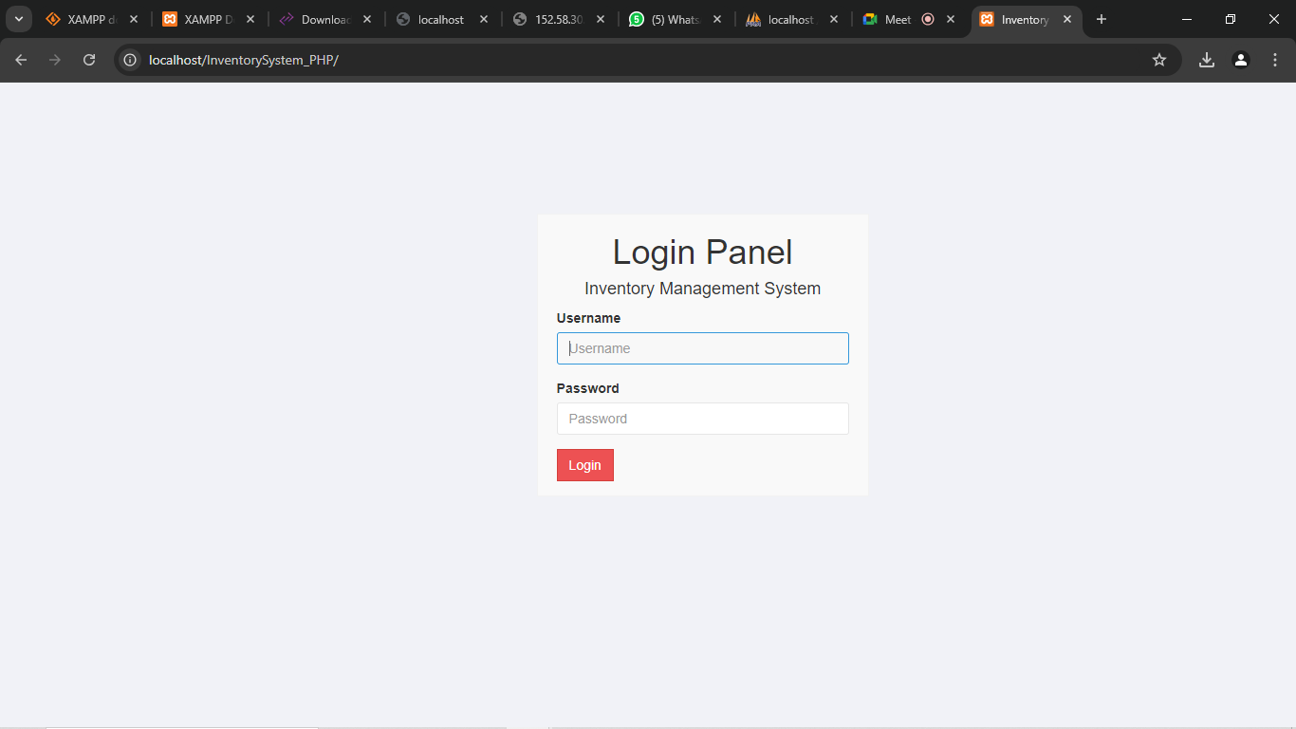

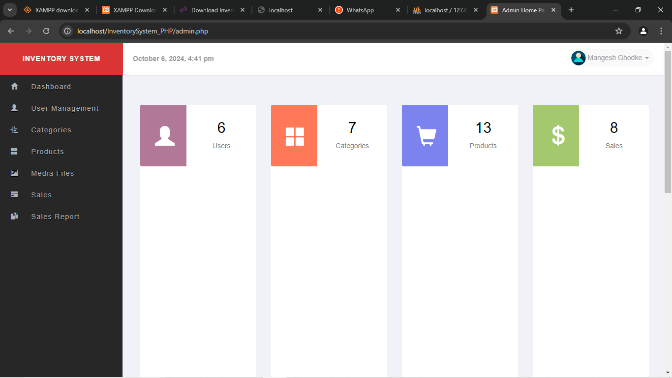
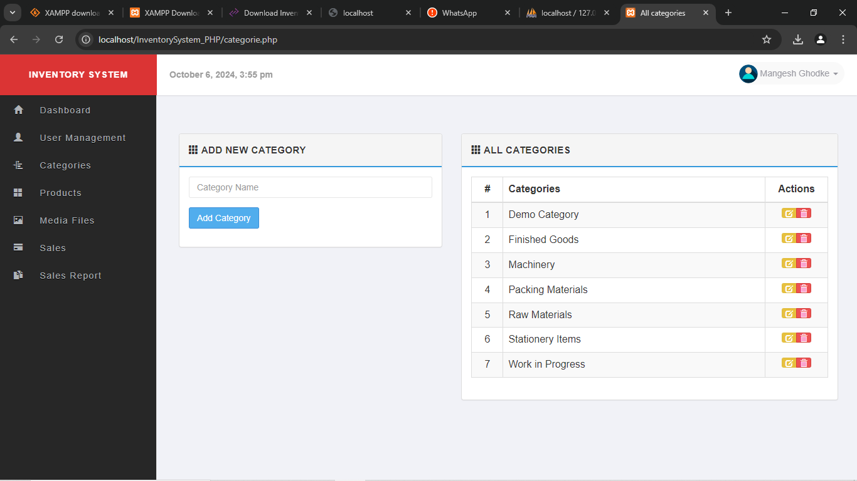

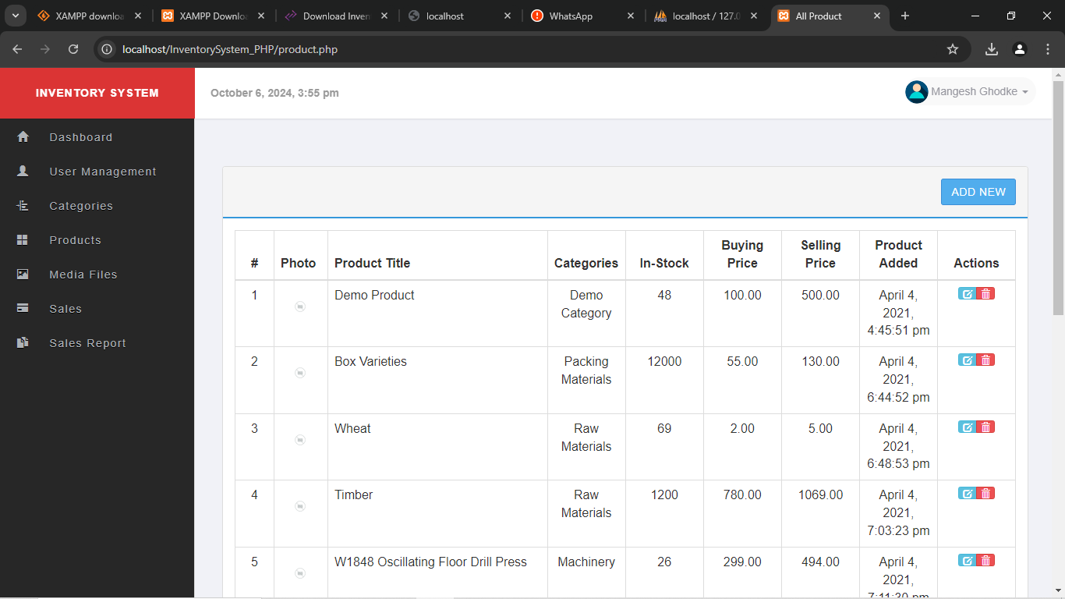
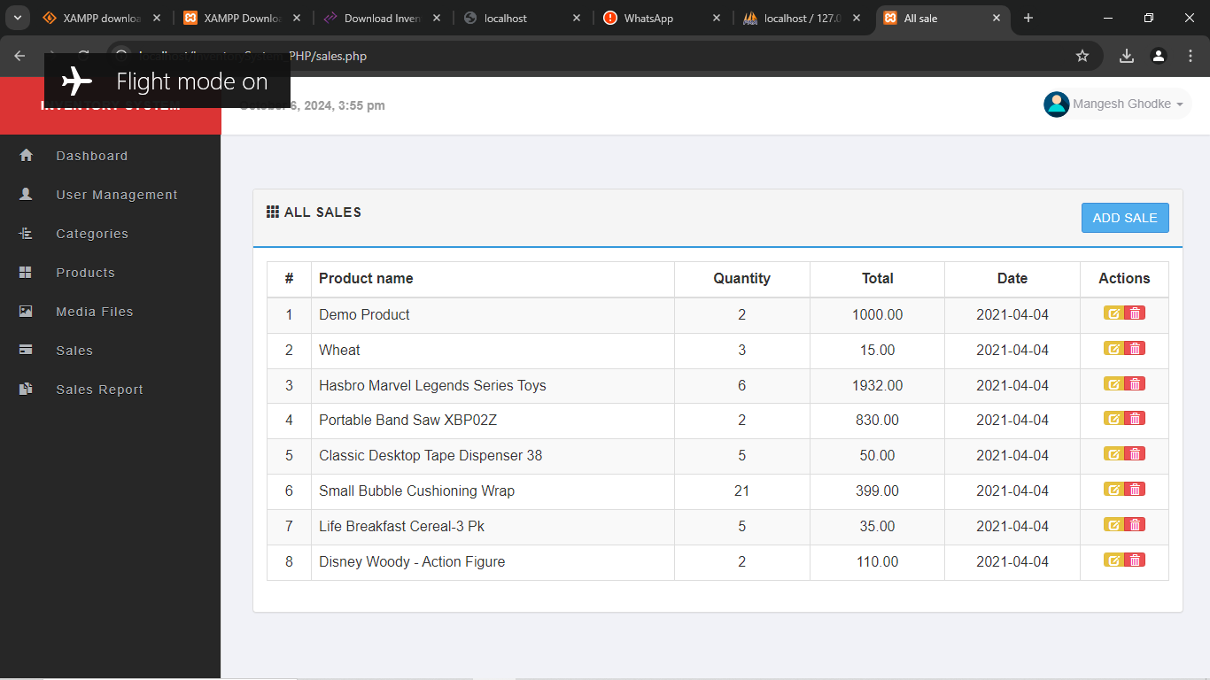

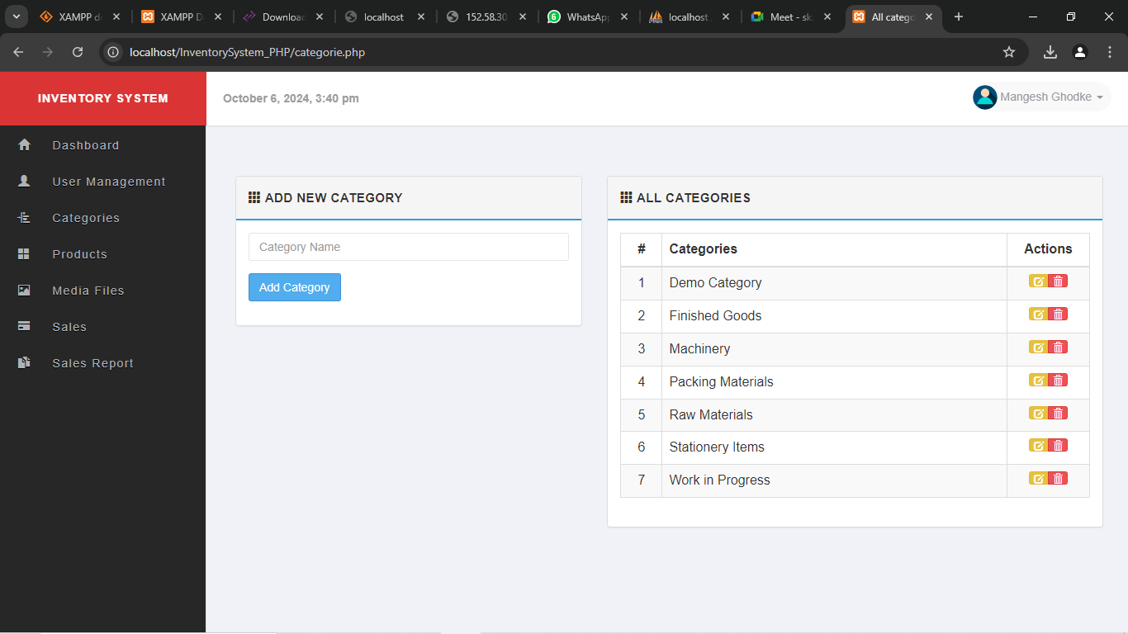
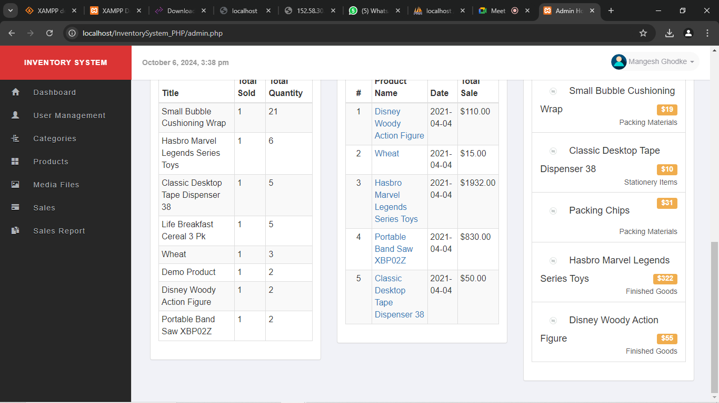

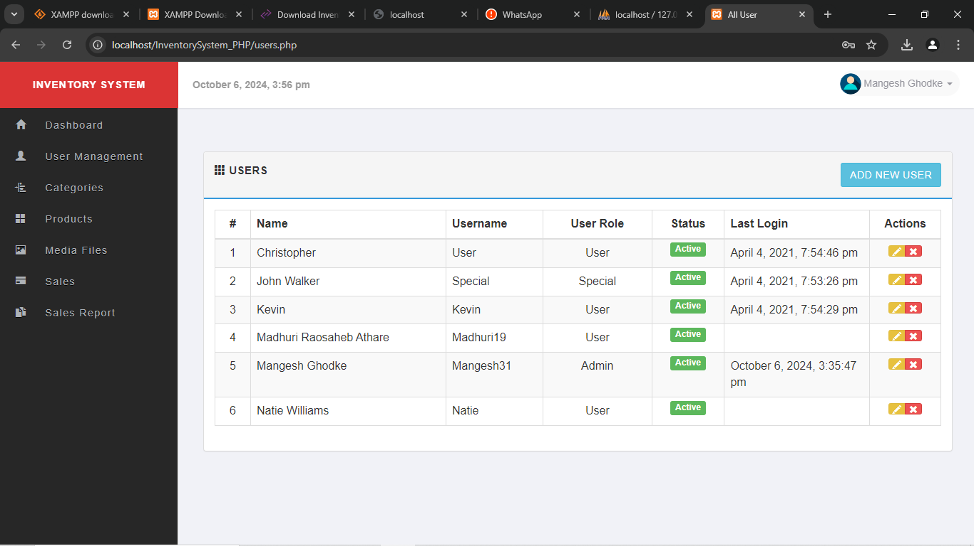

- MERITS & DEMERITS

6.1 ADVANTAGES :

1. Streamlined operations:
An IMS simplifies inventory management tasks, offering a straightforward interface that helps employees manage stock more efficiently.

2. Increased efficiency:
By automating stock tracking and order management, businesses can save valuable time that would otherwise be spent on manual processes like data entry and physical inventory checks.

3. Up-to-date inventory tracking:
Provides instant updates on stock quantities, locations, and product availability, ensuring accurate information at all times.

4. Secure order management:
An IMS ensures safe and accurate handling of transactions, purchase orders, and supplier relationships, reducing risks related to errors or security breaches.

5. Tailored stock suggestions:
The system analyzes sales patterns to offer insights and suggestions for optimal stock levels, helping businesses avoid overstock or shortages.

6. Improved workflow and customer satisfaction:
By integrating with other tools like point-of-sale (POS) systems, an IMS boosts the overall efficiency of operations, leading to faster order fulfillment and a better customer experience.

6.2 DISADVANTAGES :

1. System crashes and technical issues:
Unexpected downtimes or glitches can disrupt inventory operations, potentially leading to delays in stock management or order processing.

2. Transaction handling errors:
Errors in processing purchase orders or stock updates could result in incorrect inventory levels or lost orders, impacting business efficiency.

3. Concerns about data breaches:
Storing sensitive information like supplier details or transaction records in an IMS raises potential data security risks if not properly protected.

4. Integration challenges with other software:
The IMS may encounter difficulties integrating smoothly with existing systems like accounting, ERP, or point-of-sale (POS) software, causing compatibility issues.

5. Problems with returns and stock adjustments:
Errors in managing returns or adjustments may cause discrepancies in inventory levels, leading to stock inaccuracies or delays in processing returns.

6. Costs for implementation and maintenance:
Implementing and maintaining an IMS may involve additional fees, including licensing, training, or technical support, which could increase operational expenses.

6.3 APPLICATIONS :

1. Automated Stock Replenishment:
The IMS can automatically reorder products when inventory falls below a predefined threshold, ensuring that stock levels are maintained without manual intervention.

2. Real-Time Inventory Tracking:
The system allows businesses to monitor stock levels in real-time across multiple warehouses, ensuring accurate inventory counts and avoiding stockouts or overstock situations.

3. Order Fulfillment and Shipment Management:
By integrating the IMS with shipment modules, businesses can efficiently manage incoming and outgoing orders, track shipment statuses, and streamline the delivery process to warehouses and customers.

4. Supplier and Purchase Order Management:
The system tracks suppliers and manages purchase orders, allowing businesses to evaluate supplier performance, manage order histories, and maintain good supplier relationships.

5. Product Categorization and Management:
The IMS allows businesses to organize products by category, description, and other attributes, making it easier to track specific products and manage multiple SKUs.

6. Sales Analysis and Forecasting:
The system can analyze sales patterns and historical data, helping businesses forecast future demand and optimize inventory levels based on consumer behavior.

7. Multi-Warehouse Coordination:
If the business operates multiple warehouses, the IMS ensures seamless coordination between locations, allowing inventory transfers between warehouses and better stock distribution management.

6.3 FUTURE SCOPE :

The future scope of Inventory Management Systems (IMS) is promising, with advancements in technologies like artificial intelligence (AI) and machine learning (ML) expected to enhance demand forecasting, optimize stock levels, and automate decision-making processes. These capabilities will enable businesses to anticipate market trends and customer preferences more accurately, leading to reduced costs and improved efficiency.

Additionally, the integration of Internet of Things (IoT) and RFID technology will revolutionize inventory tracking by providing real-time updates on stock levels and product movements. This increased visibility will facilitate better warehouse management and faster order fulfillment. As businesses continue to adopt cloud-based solutions, IMS will also benefit from enhanced scalability, accessibility, and security, while incorporating sustainability features to manage resources responsibly.

CONCLUSION

In conclusion, the Inventory Management System (IMS) we developed offers a comprehensive solution for businesses to efficiently manage their stock, suppliers, and orders. By providing real-time visibility into inventory levels, automating stock replenishment, and improving order fulfillment processes, the system minimizes the risk of stockouts, overstock, and manual errors. Additionally, the integration of shipment tracking and supplier management ensures smooth operations throughout the supply chain. The system's ability to generate insights through sales analysis and forecasting also empowers businesses to make data-driven decisions, further enhancing operational efficiency.

The IMS not only optimizes inventory processes but also improves overall workflow by integrating with other essential systems, such as accounting and point-of-sale (POS) software. With its user-friendly interface, businesses can easily adapt to the system, reducing training time and operational disruption. The secure handling of transaction data and flexibility in managing multiple warehouses make the IMS a valuable tool for businesses of any size, allowing them to scale and meet growing customer demands while ensuring the integrity of their inventory management.

REFERENCES :

Research Papers:
1. " Research paper on Inventory management system" by International Research Journal of Engineering and Technology (IRJET)
2. " Inventory Management System" by International Journal of Scientific Research & Engineering Trends

Websites:
1. Zoho
2. Cin7
3. Unleashed

Books:
1. "Software Engineering: A Practitioner's Approach" by Roger S. Pressman
2. "Database Systems: The Complete Book" by Hector Garcia-Molina
3. "Web Development and Design Foundations" by Jerry D. Sanders

Online Resources:
1. GitHub ((link unavailable)) – inventory management system
2. Stack Overflow ((link unavailable)) - Programming-related questions and answers
3. CodeProject ((link unavailable)) - Programming tutorials and articles
4. W3Schools ((link unavailable)) - Web development tutorials and reference materials

Industry Reports:
1. Inventory Management Software Market Size, Share & Industry Analysis, By Deployment Mode (On-Premise and Cloud), By Application (Inventory Control and Tracking, Order Management, Scanning and Barcoding, Asset Management, and Others) by Fortune Business Insights

2. " Inventory Management Software Market Size, By Type (Manually Managed Inventory System, Barcode Scanning System, Advanced Radio Frequency System (RFID)), By Deployment Model (On-premise, Cloud), Organization Size, Application, End-Use, 2023 – 2032” by GMInsights

